https://www.tcatrains.org/etrain/galloping-goose/

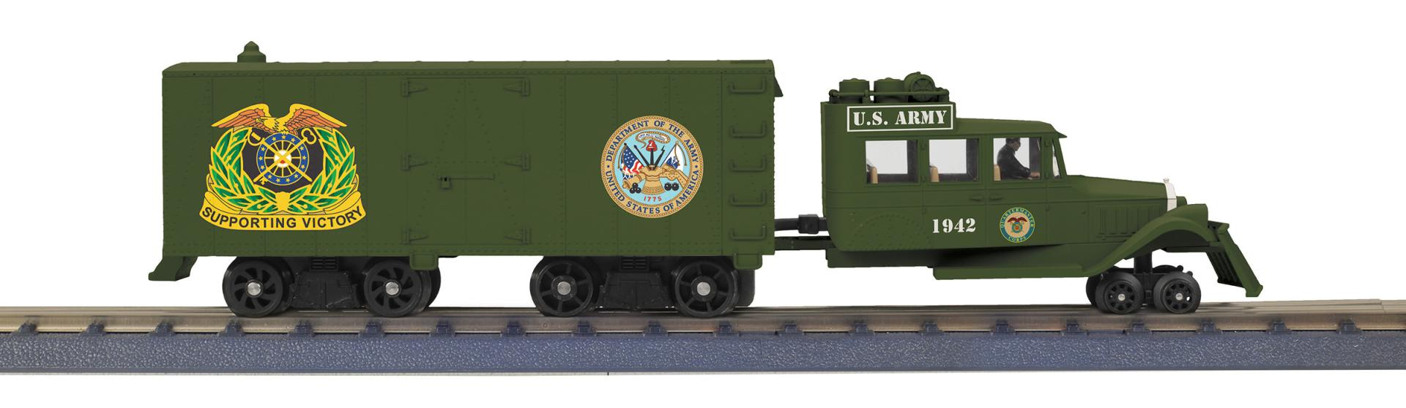

30-21315-1 U.S. Army

