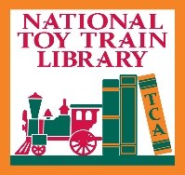 Ives Manufacturing Company in Patents

by Librarian Michaela Feltman
National Toy Train Museum and Library

Before the Ives Manufacturing Company (1868-1930) became the largest manufacturer of toy trains in the United States (1910-1924), they were known for their dolls, clockwork toys, and toy animals. At the turn of the 20th century, as competition in the American doll and toy market grew along with the emergence of electricity in households across the United States, Ives shifted their focus to toy trains and models demonstrating power electricity. But to make that happen the company and its founders: the Ives family, needed to put their ideas on paper.

U.S Patent Process

A patent gives an inventor the ability to exclude others (individuals or companies) from making, using, or selling their inventions for a certain time period. When an inventor creates something new they must ask the U.S. government for this patent by describing what they created in writing. Usually, this can be done by the inventor themselves (a patent agent) or with the help of a lawyer (a patent attorney).

But once you apply for a patent, you simply do not just get it. The government examines the application to make sure that the invention is new. They look through books and other patents to make sure that there is not something that is like the invention at hand. If the invention is proven to be new, then the government sends a copy of the patent with a special seal.
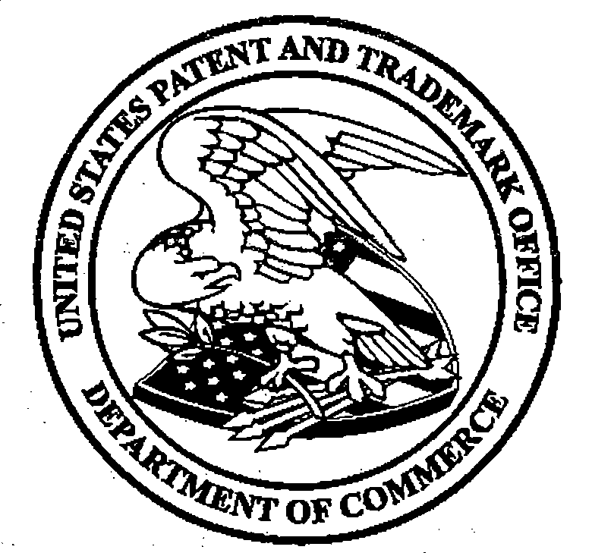

Trademark Vs. Patent

Many may think that a trademark and a patent are the same things, but they are very different. A trademark protects words and design elements that identify the source of a product. Examples of this can be brand names and logos. In this exhibit, we have the original trademark for Ives. Trademarks also include drawings which this one has the original box drawing of an Ives Box.

Ives and the Patents

The Ives company produced and was awarded countless patents for its toy train and model railroad accessory designs. Even to the smallest details of train track stops, light fixtures, and internal diagrams nothing was missed. Several visual perspectives are drawn in the patent, each part with a corresponding number that is later mentioned in the description of the patent. These drawings within the patent were later used in advertising materials for the product mentioned.

Today many of the patents created by Ives are cited in countless new inventions by toy train manufacturers.
These Ives patents are just a fraction of Toy Train-related patents that are available in the library for patrons to view or even to use for their own next big invention in the wonderful world of Model Railroad Toy Trains!!

